6 ST 20 Central processing unit
The Central Processing Unit (CPU) is the ST20 32-bit processor core. It contains instruction processing logic, instruction and data pointers, and an operand register. It can directly access the high speed on-chip memory, which can store data or programs. Where larger amounts of memory are required, the processor can access memory via the External Memory Interface (EMI). The processor provides high performance:
• Fast integer multiply - 4 cycle multiply
• Fast bit shift - single cycle barrel shifter
• Byte and part-word handling
• Scheduling and interrupt support
• 64-bit integer arithmetic support
The scheduler provides a single level of pre-emption. In addition, multi-level pre-emption is provided by the interrupt subsystem. Additionally, there is a per-priority trap handler to improve the support for arithmetic errors and illegal instructions, refer to Section 6.6: Traps and exceptions on page 33.
6.1 Registers
The CPU contains six registers which are used in the execution of a sequential integer process. The six registers are:
• The workspace pointer (Wptr) which points to an area of store where local data is kept
• The instruction pointer (Iptr) which points to the next instruction to be executed
• The status register (Status)
• The Areg, Breg and Creg registers which form an evaluation stack
The Areg, Breg and Creg registers are the sources and destinations for most arithmetic and logical operations.
Loading a value into the stack pushes Breg into Creg, and Areg into Breg, before loading Areg. Storing a value from
Areg, pops Breg into Areg and Creg into Breg. Creg is left undefined.
Expressions are evaluated on the evaluation stack, and instructions refer to the stack implicitly. For example, the add instruction adds the top two values in the stack and places the result on the top of the stack. The use of a stack removes the need for instructions to explicitly specify the location of their operands. No hardware mechanism is provided to detect that more than three values have been loaded onto the stack; it is easy for the compiler to ensure that this never happens.
Note that a location in memory can be accessed relative to the workspace pointer, enabling the workspace to be of any size. The use of shadow registers provides fast, simple and clean context switching.

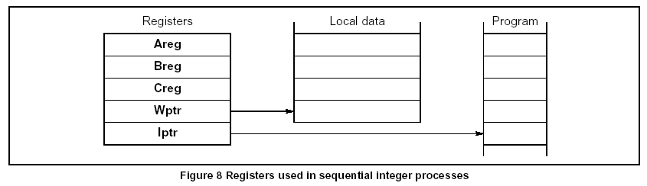

6.2 Processes and concurrency
This section describes the default behavior of the CPU and it should be noted that the user can alter this behavior, for example by disabling timeslicing or installing a user scheduler.
A process starts, performs a number of actions, and then either stops without completing or terminates complete.
Typically, a process is a sequence of instructions. The CPU can run several processes in parallel (concurrently). Processes may be assigned either high or low priority, and there may be any number of each.
The processor has a microcoded scheduler which enables any number of concurrent processes to be executed together, sharing the processor time. This removes the need for a software kernel, although kernels can still be written if desired. At any time, a process may be:
The scheduler operates in such a way that inactive processes do not consume any processor time. Each active high priority process executes until it becomes inactive. The scheduler allocates a portion of the processor’s time to each active low priority process in turn (see Section 6.3: Priority on page 31). Active processes waiting to be executed are held in two linked lists of process work spaces, one of high priority processes and one of low priority processes. Each
list is implemented using two registers, one of which points to the first process in the list, the other to the last. In the linked process list shown in Figure 9 below, process S is executing and P, Q and R are active, awaiting execution. Only the low priority process queue registers are shown; the high priority process ones behave in a similar manner.
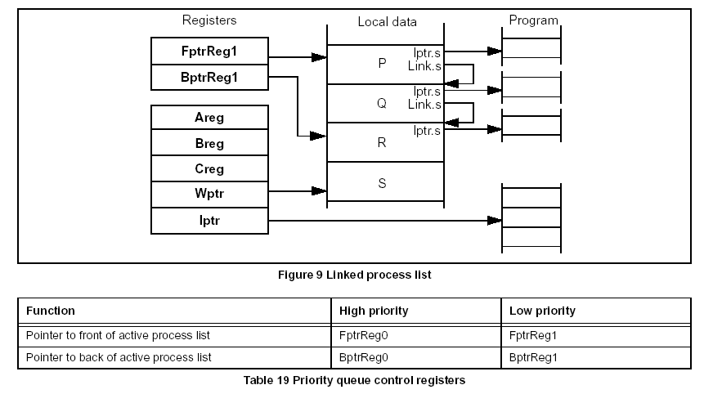

Each process runs until it has completed its action or is descheduled. In order for several processes to operate in parallel, a low priority process is only permitted to execute for a maximum of two timeslice periods. After this, the machine deschedules the current process at the next timeslicing point, adds it to the end of the low priority scheduling list and instead executes the next active process. The timeslice period is 1ms. There are only certain instructions at which a process may be descheduled. These are known as descheduling points. A process may only be timesliced at certain descheduling points. These are known as timeslicing points and are defined in such a way that the operand stack is always empty. This removes the need for saving the operand stack when timeslicing. As a result, an expression evaluation can be guaranteed to execute without the process being timesliced part way through. Whenever a process is unable to proceed, its instruction pointer is saved in the process workspace and the next process taken from the list. The processor core provides a number of special instructions to support the process model, including startp (start process) and endp (end process). When a main process executes a parallel construct, startp is used to create the necessary additional concurrent processes. A startp instruction creates a new process by adding a new workspace to the end of the scheduling list, enabling the new concurrent process to be executed together with the ones already being
executed. When a process is made active it is always added to the end of the list, and thus cannot pre-empt processes already on the same list. The correct termination of a parallel construct is assured by use of the endp instruction. This uses a data structure that includes a counter of the parallel construct components which have still to terminate. The counter is initialized to the number of components before the processes are started. Each component ends with an endp instruction which decrements and tests the counter. For all but the last component, the counter is non zero and the component is descheduled. For the last component, the counter is zero and the main process continues.
6.3 Priority
The following section describes ‘default’ behavior of the CPU and it should be noted that the user can alter this behavior, for example, by disabling timeslicing and priority interrupts. The processor can execute processes at one of two priority levels, one level for urgent (high priority) processes, one for less urgent (low priority) processes. A high priority process will always execute in preference to a low priority process if both are able to do so. High priority processes are expected to execute for a short time. If one or more high priority processes are active, then the first on the queue is selected and executes until it has to wait for a communication, a timer input, or until it completes processing. If no process at high priority is active, but one or more processes at low priority are active, then one is selected. Low priority processes are periodically timesliced to provide an even distribution of processor time between tasks which use a lot of computation.
If there are n low priority processes, then the maximum latency from the time at which a low priority process becomes active to the time when it starts processing is the order of 2 n timeslice periods. It is then able to execute for between one and two timeslice periods, less any time taken by high priority processes. This assumes that no process monopolizes the time of the CPU; i.e. it has frequent timeslicing points. The specific condition for a high priority process to start execution is that the CPU is idle or running at low priority and the high priority queue is non-empty. If a high priority process becomes able to run while a low priority process is executing, the low priority process is temporarily stopped and the high priority process is executed. The state of the low priority process is saved into ‘shadow’ registers and the high priority process is executed. When no further high priority processes are able to run, the state of the interrupted low priority process is re-loaded from the shadow registers and the interrupted low priority process continues executing. Instructions are provided on the processor core to allow a high priority process to store
the shadow registers to memory and to load them from memory. Instructions are also provided to allow a process to exchange an alternative process queue for either priority process queue. These instructions allow extensions to be made to the scheduler for custom run-time kernels.

A low priority process may be interrupted after it has completed execution of any instruction. In addition, to minimize the time taken for an interrupting high priority process to start executing, the potentially time consuming instructions are interruptible. Also some instructions may be aborted, and are restarted when the process next becomes active (see Instruction set on page 38).
6.4 Process communications
Communication between processes takes place over channels, and is implemented in hardware. Communication is point-to-point, synchronized and unbuffered. As a result, a channel needs no process queue, no message queue and no message buffer. A channel between two processes executing on the same CPU is implemented by a single word in memory; a channel between processes executing on different processors is implemented by point-to-point links. The
processor provides a number of operations to support message passing, the most important being in (input message) and out (output message). The in and out instructions use the address of the channel to determine whether the channel is internal or external. This means that the same instruction sequence can be used for both hard and soft channels, allowing a process to be written and compiled without knowledge of where its channels are implemented. Communication takes place when both the inputting and outputting processes are ready. Consequently, the process which first becomes ready must wait until the second one is also ready. The inputting and outputting processes only become active when the communication has completed. A process performs an input or output by loading the evaluation stack with, a pointer to a message, the address of a channel, and a count of the number of bytes to be transferred, and then executing an in or out instruction.
6.5 Timers
There are two 32-bit hardware timer clocks which ‘tick’ periodically. These are independent of any on-chip peripheral real time clock. The timers provide accurate process timing, allowing processes to deschedule themselves until a specific time. One timer is accessible only to high priority processes and is incremented approximately every microsecond, cycling completely in approximately 4295 seconds. The other is accessible only to low priority processes and runs 64 times slower, giving 15625 ticks per second. It has a full period of approximately 76 hours.
Actual timer speeds are derived from the processor speed ProcClockOut and are given in the Clocks chapter. The periods may be calculated as follows:

High_priority_clock_period = 1μs × Nominal_speed / ProcClockOut _speed
Low_priority_clock_period = High_priority_clock_period x 64
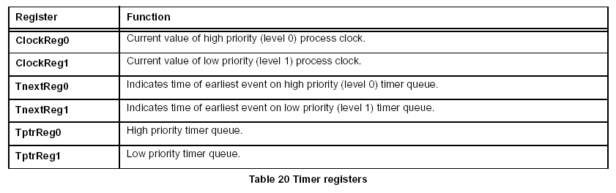
The current value of the processor clock can be read by executing a ldtimer (load timer) instruction. A process can arrange to perform a tin (timer input), in which case it will become ready to execute after a specified time has been reached. The tin instruction requires a time to be specified. If this time is in the ‘past’ then the instruction has no effect. If the time is in the ‘future’ then the process is descheduled. When the specified time is reached the process becomes
active. In addition, the ldclock (load clock), stclock (store clock) instructions allow total control over the clock value and the clockenb (clock enable), clockdis (clock disable) instructions allow each clock to be individually stopped and restarted.
Figure 10 shows two processes waiting on the timer queue, one waiting for time 21, the other for time 31.
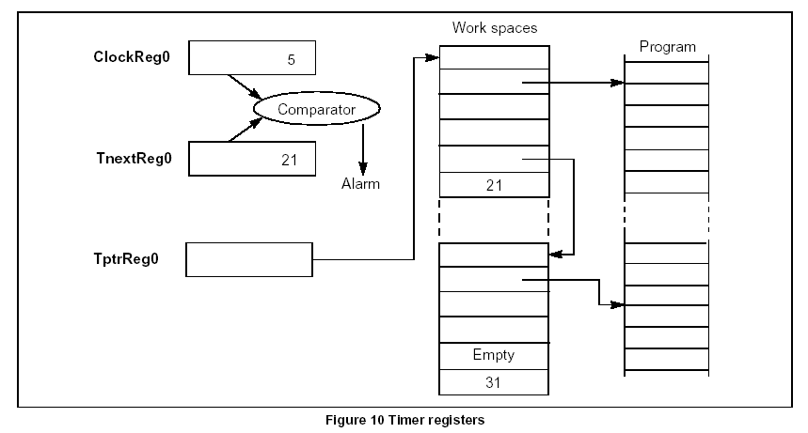
6.6 Traps and exceptions
A software error, such as arithmetic overflow or array bounds violation, can cause an error flag to be set in the CPU. The flag is directly connected to the ErrorOut pin. Both the flag and the pin can be ignored, or the CPU stopped. Stopping the CPU on an error means that the error cannot cause further corruption. As well as containing the error in this way it is possible to determine the state of the CPU and its memory at the time the error occurred. This is particularly useful for
postmortem debugging where the debugger can be used to examine the state and history of the processor leading up to and causing the error condition. In addition, if a trap handler process is installed, a variety of traps/exceptions can be trapped and handled by software. A user supplied trap handler routine can be provided for each high/low process priority level. The handler is started when a trap occurs and is given the reason for the trap. The trap handler is not re-entrant
and must not cause a trap itself within the same group. All traps can be individually masked.

6.6.1 Trap groups
The trap mechanism is arranged on a per priority basis. For each priority there is a handler for each group of traps, as shown in Figure 11.

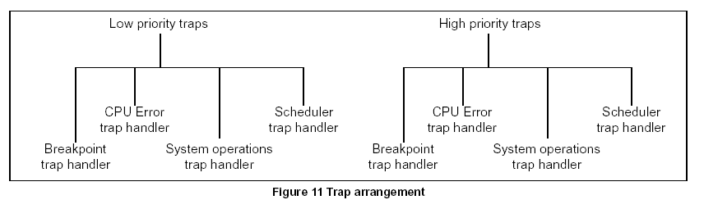
There are four groups of traps, as detailed below.
• Breakpoint: This group consists of the Breakpoint trap. The breakpoint instruction ( j0) calls the breakpoint routine via the trap mechanism.
• Errors: The traps in this group are IntegerError and Overflow. Overflow represents arithmetic overflow, such as arithmetic results which do not fit in the result word. IntegerError represents errors caused when data is erroneous, for example when a range checking instruction finds that data is out of range.
• System operations: This group consists of the LoadTrap, StoreTrap and IllegalOpcode traps. The IllegalOpcode trap is signalled when an attempt is made to execute an illegal instruction. The LoadTrap and StoreTrap traps allow a kernel to intercept attempts by a monitored process to change or examine trap handlers or trapped process information. It enables a user program to signal to a kernel that it wishes to install a new trap handler.
• Scheduler: The scheduler trap group consists of the ExternalChannel, InternalChannel, Timer, TimeSlice, Run, Signal, ProcessInterrupt and QueueEmpty traps. The ProcessInterrupt trap signals that the machine has performed a priority interrupt from low to high. The QueueEmpty trap indicates that there is no further executable work to perform. The other traps in this group indicate that the hardware scheduler wants to schedule a process on a process queue, with the different traps enabling the different sources of this to be monitored. The scheduler traps enable a software scheduler kernel to use the hardware scheduler to implement a multi-priority software scheduler. Note that scheduler traps are different from other traps as they are caused by the micro-scheduler rather than by an executing process.
Trap groups encoding is shown in Table 21 below. These codes are used to identify trap groups to various instructions.

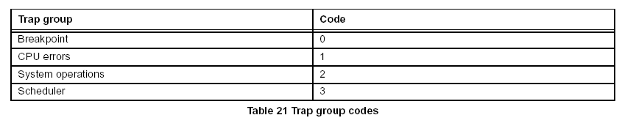
In addition to the trap groups mentioned above, the CauseError flag in the Status register is used to signal when a trap condition has been activated by the causeerror instruction. It can be used to indicate when trap conditions have occurred due to the user setting them, rather than by the system.

6.6.2 Events that can cause traps
Table 22 summarizes the events that can cause traps, and gives the encoding of bits in the trap
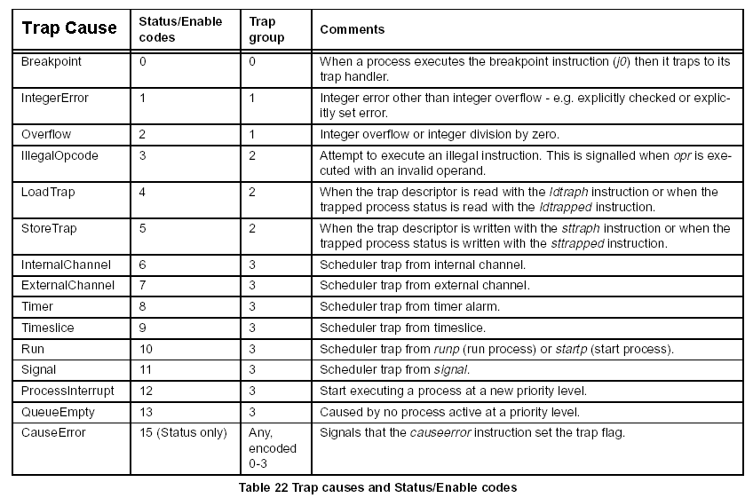
6.6.3 Trap handlers
For each trap handler there is a trap handler structure and a trapped process structure. Both the trap handler structure and the trapped process structure are in memory and can be accessed via instructions. The trap handler structure specifies what should happen when a trap condition is present, see Table 23. The trapped process structure saves some of the state of the process that was running when the trap was taken, see Table 24. In addition, for each priority, there is an Enables register and a Status register. The Enables register contains flags to enable each cause of trap. The Status register contains flags to indicate which trap conditions have been detected. The Enables and Status register bit encodings are given in Table 22 on page 35.
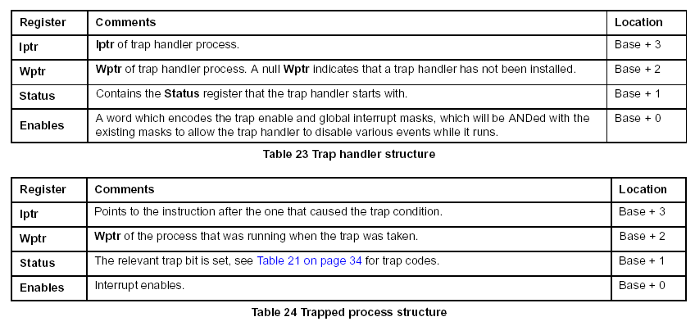
A trap will be taken at an interruptible point if a trap is set and the corresponding trap enable bit is set in the Enables register. If the trap is not enabled then nothing is done with the trap condition. If the trap is enabled then the corresponding bit is set in the Status register to indicate the trap condition has occurred. When a process takes a trap the processor saves the existing Iptr, Wptr, Status and Enables in the trapped process structure. It then loads Iptr, Wptr and Status from the equivalent trap handler structure and ANDs the value in Enables with the value in the structure. This allows the user to disable various events while in the handler, in particular a trap
handler must disable all the traps of its trap group to avoid the possibility of a handler trapping to itself. The trap handler then executes. The values in the trapped process structure can be examined using the ldtrapped instruction. When the trap handler has completed its operation it returns to the trapped process via the tret (trap return) instruction. This reloads the values saved in the trapped process structure and clears the trap flag in Status. Note that when a trap handler is started, Areg, Breg and Creg are not saved. The trap handler must save the Areg, Breg, Creg registers using stl (store local).

6.6.4 Trap instructions
Trap handlers and trapped processes can be set up and examined via the ldtraph, sttraph, ldtrapped and strapped instructions. Table 25 describes the instructions that may be used when dealing with traps.
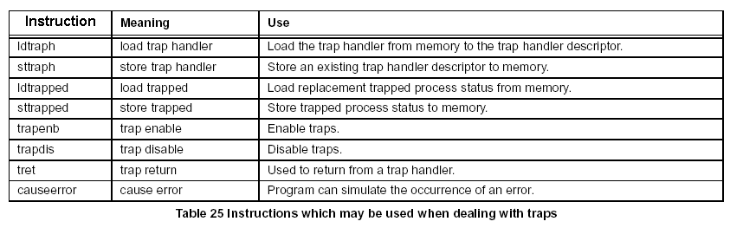
The first four instructions transfer data to/from the trap handler structures or trapped process structures from/to an area in memory. In these instructions Areg contains the trap group code (see Table 21 on page 34) and Breg points to the 4 word area of memory used as the source or destination of the transfer. In addition Creg contains the priority of the handler to be installed/examined in the case of ldtraph or sttraph. ldtrapped and sttrapped apply only to the current priority. If the LoadTrap trap is enabled then ldtraph and ldtrapped do not perform the transfer but set the LoadTrap trap flag. If the StoreTrap trap is enabled then sttraph and sttrapped do not perform the transfer but set the StoreTrap trap flag. The trap enable masks are encoded by an array of bits (see Table 22 on page 35) which are set to indicate which traps are enabled. This array of bits is stored in the lower half-word of the Enables register. There is an Enables register for each priority. Traps are enabled or disabled by loading a mask into Areg with bits set to indicate which traps are to be affected and the priority to affect in Breg. Executing trapenb ORs the mask supplied in Areg with the trap enables mask in the Enables register for the priority in Breg. Executing trapdis negates the mask supplied in Areg and ANDs it with the trap enables mask in the Enables register for the priority in Breg. Both instructions return the previous value of the trap enables mask in Areg.
6.6.5 Restrictions on trap handlers
There are various restrictions that must be placed on trap handlers to ensure that they work correctly.
• Trap handlers must not deschedule or timeslice. Trap handlers alter the Enables masks, therefore they must not allow other processes to execute until they have completed.
• Trap handlers must have their Enable masks set to mask all traps in their trap group to avoid the possibility of a trap handler trapping to itself.
• Trap handlers must terminate via the tret (trap return) instruction . The only exception to this is that a scheduler kernel may use restart to return to a previously shadowed process.
7 Instruction set
This chapter provides information on the ST20-C2 instruction set. It contains tables listing all the instructions, and where applicable provides details of the number of processor cycles taken by an instruction. The instruction set has been designed for simple and efficient compilation of high-level languages. All instructions have the same format, designed to give a compact representation of the operations occurring most frequently in programs. Each instruction consists of a single byte divided into two 4-bit parts. The four most significant bits (MSB) of the byte are
a function code and the four least significant bits (LSB) are a data value, as shown in Figure 12.

For further information on the instruction set refer to the ST20C2 Instruction Set Manual (document number 72-TRN-273).
7.1 Instruction cycles
Timing information is available for some instructions. However, it should be noted that many instructions have ranges of timings which are data dependent. Where included, timing information is based on the number of clock cycles assuming any memory accesses are to 2 cycle internal memory and no other subsystem is using memory. Actual time will be dependent on the speed of external memory and memory bus availability. Note that the actual time can be increased by:
• The instruction requiring a value on the register stack from the final memory read in the previous instruction – the current instruction will stall until the value becomes available.
• The first memory operation in the current instruction can be delayed while a preceding memory operation completes - any two memory operations can be in progress at any time, any further operation will stall until the first completes.
• Memory operations in current instructions can be delayed by access by instruction fetch or subsystems to the memory interface.
• There can be a delay between instructions while the instruction fetch unit fetches and partially decodes the next instruction – this will be the case whenever an instruction causes the instruction flow to jump. Note that the instruction timings given refer to ‘standard’ behavior and may be different if, for example, traps are set by the instruction.
7.2 Instruction characteristics
Table 28 on page 40 gives the basic function code of each of the primary instructions. Where the operand is less than 16, a single byte encodes the complete instruction. If the operand is greater than 15, one prefix instruction ( pfix) is required for each additional four bits of the operand. If the operand is negative the first prefix instruction will be nfix. Examples of pfix and nfix coding are given in Table 26 below.
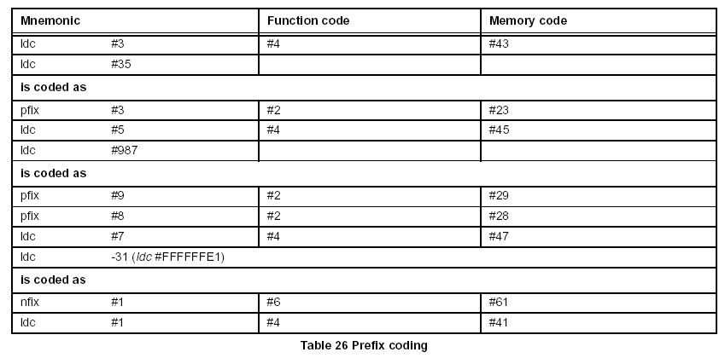
Any instruction which is not in the instruction set tables is an invalid instruction and is flagged illegal, returning an error code to the trap handler, if loaded and enabled. The Notes column of the tables indicates the features of an instruction as described in Table 27.
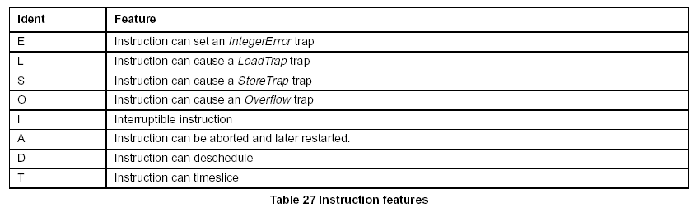
7.3 Instruction set tables
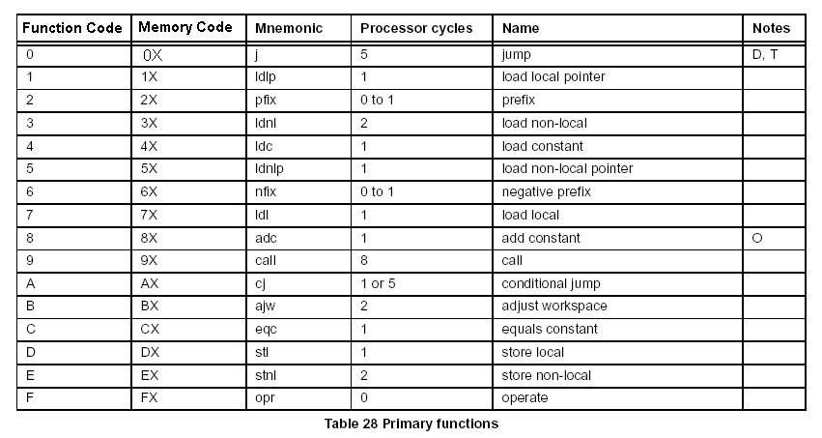
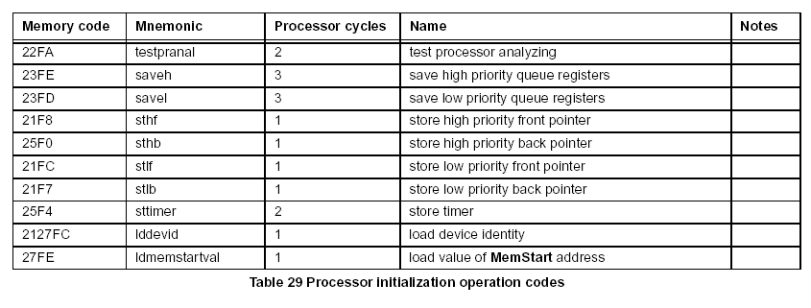

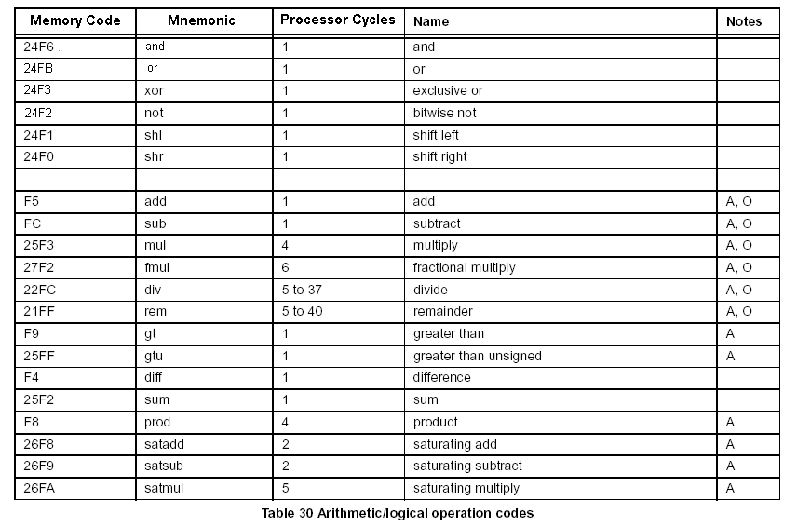
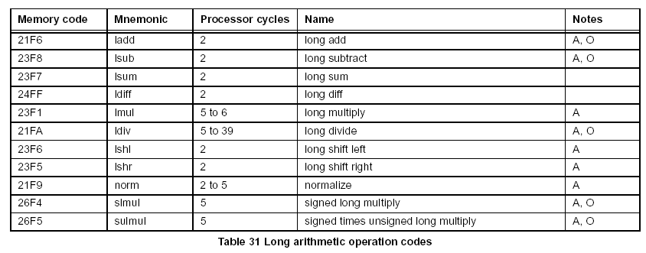

Memory code Mnemonic Processor cycles Name Notes
F0 rev 1 reverse
23FA xword 4 extend to word A
25F6 cword 3 check word A, E
21FD xdble 2 extend to double
24FC csngl 3 check single A, E
24F2 mint 1 minimum integer
25FA dup 1 duplicate top of stack
27F9 pop 1 pop processor stack
68FD reboot 1 reboot

Table 32 General operation codes

Memory code Mnemonic Processor cycles Name Notes
F2 bsub 1 byte subscript
FA wsub 1 word subscript
28F1 wsubdb 1 form double word subscript
23F4 bcnt 1 byte count
23FF wcnt 1 word count
F1 lb 1 load byte
23FB sb 2 store byte
24FA move move message I

Table 33 Indexing/array operation codes

Memory code Mnemonic Processor cycles Name Notes
22F2 ldtimer 1 load timer
22FB tin timer input I
24FE talt 3 timer alt start
25F1 taltwt timer alt wait D, I
24F7 enbt 2 to 8 enable timer
22FE dist disable timer I

Table 34 Timer handling operation codes
Memory code Mnemonic Processor cycles Name Notes
21F3 csub0 2 check subscript from 0 A, E
24FD ccnt1 3 check count from 1 A, E
22F9 testerr 2 test error false and clear
21F0 seterr 2 set error
25F5 stoperr 2 to 3 stop on error (no error) D
25F7 clrhalterr 1 clear halt-on-error
25F8 sethalterr 1 set halt-on-error
25F9 testhalterr 2 test halt-on-error

Table 38 Error handling operation codes
Memory code Mnemonic Processor cycles Name Notes
25FB move2dinit 3 initialize data for 2D block move
25FC move2dall 2D block copy I
25FD move2dnonzero 2D block copy non-zero bytes I
25FE move2dzero 2D block copy zero bytes I

Table 39 2D block move operation codes
Memory code Mnemonic Processor cycles Name Notes
27F4 crcword 36 calculate crc on word A
27F5 crcbyte 12 calculate crc on byte A
27F6 bitcnt 3 count bits set in word A
27F7 bitrevword 2 reverse bits in word
27F8 bitrevnbits 2 reverse bottom n bits in word A

Table 40 CRC and bit operation codes
Memory code Mnemonic Processor cycles Name Notes
27F3 cflerr 3 check floating point error E
29FC fptesterr 1 load value true (FPU not present)
26F3 unpacksn 10 unpack single length floating point number A
26FD roundsn 7 round single length floating point number A
26FC postnormsn 9 post-normalize correction of single length floating
point number A
27F1 ldinf 1 load single length infinity

Table 41 Floating point support operation codes
Memory code Mnemonic Processor cycles Name Notes
2CF7 cir 3 check in range A, E
2CFC ciru 3 check in range unsigned A, E
2BFA cb 3 check byte A, E
2BFB cbu 2 check byte unsigned A, E
2FFA cs 3 check sixteen A, E
2FFB csu 2 check sixteen unsigned A, E
2FF8 xsword 3 sign extend sixteen to word A
2BF8 xbword 3 sign extend byte to word A

Table 42 Range checking and conversion instructions
Memory code Mnemonic Processor cycles Name Notes
2CF1 ssub 1 sixteen subscript
2CFA ls 1 load sixteen
2CF8 ss 2 store sixteen
2BF9 lbx 1 load byte and sign extend
2FF9 lsx 1 load sixteen and sign extend

Table 43 Indexing/array instructions
Memory code Mnemonic Processor cycles Name Notes
2FF0 devlb 3 device load byte A
2FF2 devls 3 device load sixteen A
2FF4 devlw 3 device load word A
62F4 devmove device move I
2FF1 devsb 3 device store byte A
2FF3 devss 3 device store sixteen A
2FF5 devsw 3 device store word A

Table 44 Device access instructions
Memory code Mnemonic Processor cycles Name Notes
60F5 wait 5 to 11 wait D
60F4 signal 7 to 12 signal

Table 45 Semaphore instructions
Memory code Mnemonic Processor cycles Name Notes
60F0 swapqueue 4 swap scheduler queue
60F1 swaptimer 5 swap timer queue
60F2 insertqueue 3 to 4 insert at front of scheduler queue
60F3 timeslice 3 to 4 timeslice
60FC ldshadow 6 to 31 load shadow registers A
60FD stshadow 6 to 17 store shadow registers A
62FE restart 20 restart
62FF causeerror 7 to 8 cause error
61FF iret 3 to 11 interrupt return
2BF0 settimeslice 2 set timeslicing status
2CF4 intdis 2 interrupt disable
2CF5 intenb 2 interrupt enable
2CFD gintdis 5 global interrupt disable
2CFE gintenb 5 global interrupt enable

Table 46 Scheduling support instructions
Memory code Mnemonic Processor cycles Name Notes
26FE ldtraph 12 load trap handler L
2CF6 ldtrapped 12 load trapped process status L
2CFB sttrapped 12 store trapped process status S
26FF sttraph 12 store trap handler S
60F7 trapenb 4 trap enable
60F6 trapdis 4 trap disable
60FB tret 8 to 10 trap return

Table 47 Trap handler instructions
Memory code Mnemonic Processor cycles Name Notes
68FC ldprodid 1 load product identity
63F0 nop 1 no operation

Table 48 Processor initialization and no operation instructions
Memory code Mnemonic Processor cycles Name Notes
64FF clockenb 2 clock enable
64FE clockdis 2 clock disable
64FD ldclock 2 load clock
64FC stclock 2 store clock

Table 49 Clock instructions
8 Interrupt system
The interrupt system allows an on-chip module or external interrupt pin to interrupt the currently running process in order to run an interrupt handling process.
An interrupt may be signalled by one of the following:
• a signal on an external Interrupt pin
• a signal from an internal peripheral or subsystem
• software asserting an interrupt in the Pending register
Interrupts are implemented using an on-chip interrupt controller peripheral and an on-chip interrupt level controller. The interrupt level controller (described in Interrupt level controller on page 50) multiplexes incoming interrupts onto the eight programmable interrupt inputs of the interrupt controller. This multiplexing is controllable by software.
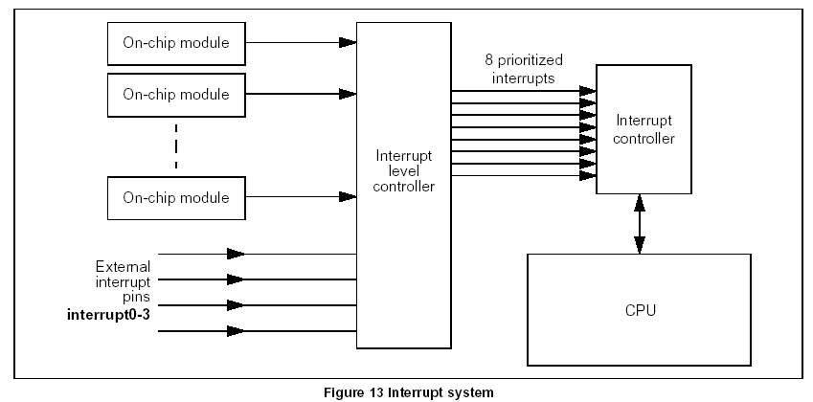
The interrupt controller supports eight prioritized interrupts as inputs, and manages the pending interrupts. This allows nested pre-emptive interrupts for real-time system design. All interrupts are at a higher priority than the low priority process queue. Each interrupt can be programmed to be at a lower or higher priority than the high priority process queue, by writing to the priority bit in the HandlerWptr registers. Interrupts which are specified as higher priority must be contiguous from the highest numbered interrupt downwards. For example, if 4 interrupts are programmed as higher priority and 4 as l ower priority the higher priority interrupts must be Interrupt7:4 and the lower priority interrupts Interrupt3:0.
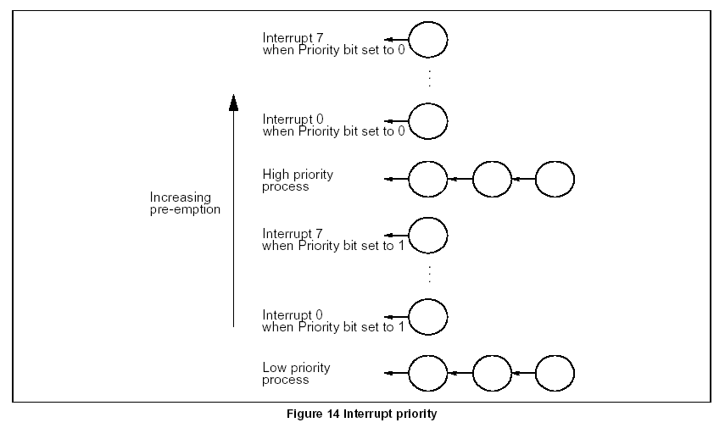
8.1 Interrupt vector table
The interrupt controller contains a table of pointers to interrupt handlers. Each interrupt handler is represented by its work space pointer (HandlerWptr). The table contains a work space pointer for each level of interrupt. The HandlerWptr gives access to the code, data and interrupt save space of the interrupt handler. The position of the HandlerWptr in the interrupt table implies the priority of the interrupt. Run-time library support is provided for setting and programming the vector table.
8.2 Interrupt handlers
At any interruptible point in its execution the CPU can receive an interrupt request from the interrupt controller. The CPU immediately acknowledges the request.

In response to receiving an interrupt the CPU performs a procedure call to the process in the vector table. The state of the interrupted process is stored in the work space of the interrupt handler as shown in Figure 15 below. Each interrupt level has its own work space.
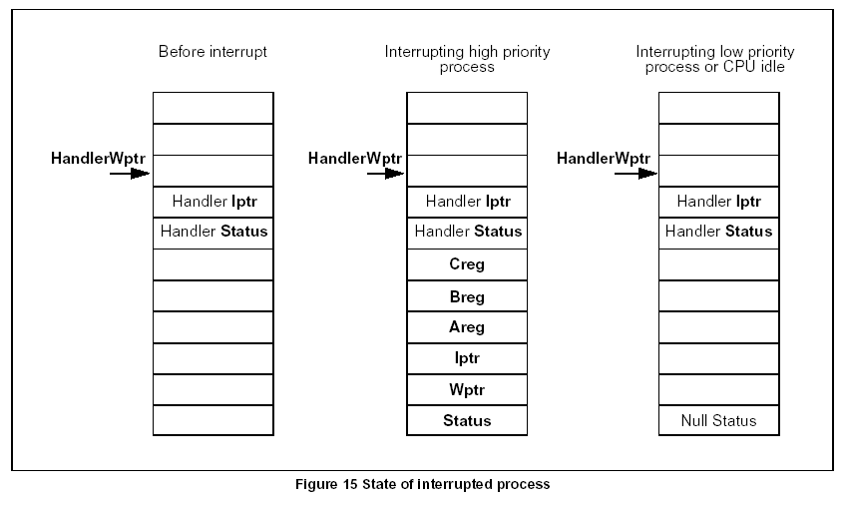
The interrupt routine is initialized with space below HandlerWptr. The Iptr and Status word for the routine are stored there permanently. This should be programmed before the HandlerWptr is written into the vector table. The behavior of the interrupt differs depending on the priority of the CPU when the interrupt occurs. If an interrupt occurs when the CPU is running at high priority, and the interrupt is set at a higher priority than the high priority process queue, the CPU saves the current process state (Areg, Breg, Creg, Wptr, Iptr and Status) into the workspace of the
interrupt handler. The value HandlerWptr, which is stored in the interrupt controller, points to the top of this work space. The values of Iptr and Status to be used by the interrupt handler are loaded from this work space and starts executing the handler. The value of Wptr is then set to the bottom of this save area. If an interrupt occurs when the CPU is running at high priority, and the interrupt is set at a lower priority than the high priority process queue, no action is taken and the interrupt waits in a queue until the high priority process queue is empty (see Section 8.4: Pre-emption and interrupt priority on page 50). Interrupts always take priority over low priority processes. If an interrupt occurs when the CPU was idle or running at low priority, the Status is saved. This indicates that no valid process is running ( Null Status). The interrupted processes
(low priority process) state is stored in shadow registers. This state can be accessed via the ldshadow (load shadow registers) and stshadow (store shadow registers) instructions. The interrupt handler is then run at high priority. When the interrupt routine has completed it must adjust Wptr to the value at the start of the handler code and then execute the iret (interrupt return) instruction. This restores the interrupted state from the interrupt handler structure and
signals to the interrupt controller that the interrupt has completed. The processor will then continue from where it was before being interrupted.
8.3 Interrupt latency
The interrupt latency is dependent on the data being accessed and the position of the interrupt handler and the interrupted process. This allows systems to be designed with the best trade-off use of fast internal memory and interrupt latency.
8.4 Pre-emption and interrupt priority
Each interrupt channel has an implied priority fixed by its place in the interrupt vector table. All interrupts will cause scheduled processes of any priority to be suspended and the interrupt handler started. Once an interrupt has been sent from the controller to the CPU the controller keeps a record of the current executing interrupt priority. This is only cleared when the interrupt handler executes a return from interrupt ( iret) instruction. Interrupts of a lower priority arriving
will be blocked by the interrupt controller until the interrupt priority has descended to such a level that the routine will execute. An interrupt of a higher priority than the currently executing handler will be passed to the CPU and cause the current handler to be suspended until the higher priority interrupt is serviced. In this way interrupts can be nested and a higher priority interrupt will always pre-empt a lower priority one. Deep nesting and placing frequent interrupts at high priority can result in a system where low priority interrupts are never serviced or the controller and CPU time are consumed in nesting interrupt priorities and not executing the interrupt handlers.
8.5 Restrictions on interrupt handlers
There are various restrictions that must be placed on interrupt handlers to ensure that they interact correctly with the rest of the process model implemented in the CPU.
• Interrupt handlers must not deschedule.
• Interrupt handlers must not execute communication instructions. However they may communicate with other processes through shared variables using the semaphore signal to synchronize.
• Interrupt handlers must not perform 2D block move instructions.
• Interrupt handlers must not cause program traps. However they may be trapped by a scheduler trap.
8.6 Interrupt level controller
The interrupt level controller multiplexes twenty three incoming interrupt signals onto the eight interrupt inputs of the interrupt controller. In this way, it gives programmable control of the priority of the interrupts and extends the number of possible interrupts to twenty three. There are twenty three interrupt signals to be handled by the interrupt subsystem. They may be generated by other onchip subsystems or be received from external pins. Software assigns signal n to one of the 8 inputs to the interrupt controller by writing the priority of the required input in the register Int nPriority. Thus each input of the interrupt controller responds to zero or more of the twenty three system interrupts. The interrupt level controller asserts interrupt output p when one or more of the input interrupts with programmed priority equal to p are high. It is level sensitive.
Where two or more system interrupts are assigned to one interrupt handler, the routine is able to ascertain the source of an interrupt by doing a device read from the InputInterrupts register and examining the bits that correspond to the system interrupts assigned to that handler.
8.7 Interrupt assignments
The interrupts from the internal peripherals and external pins on the STi5512 are assigned as shown in the table below.
Interrupt Peripheral Pin Notes
0 Port 0 Compare function on PIO port.
1 Port 1 Compare function on PIO port.
2 Port 2 Compare function on PIO port.
3 Port 3 Compare function on PIO port.
4 Port 4 Compare function on PIO port.
5 SSC0 OR of signals SSC0TIR, SSC0RIR, SSC0EIR.
6 SSC1 OR of signals SSC1TIR, SSC1RIR, SSC1EIR.
7 ASC3 OR of signals ASC3TIR, ASC3TBIR, ASC3RIR, ASC3EIR.
8 ASC2 OR of signals ASC2TIR, ASC2TBIR, ASC2RIR, ASC2EIR.
9 ASC1 OR of signals ASC1TIR, ASC1TBIR, ASC1RIR, ASC1EIR.
10 ASC0 OR of signals ASC0TIR, ASC0TBIR, ASC0RIR, ASC0EIR.
11 PWM and Capture OR of signals PWM0Int, PWM1Int, Capture0Int, Capture1Int.
12 P1284 IEEE1284 parallel port DMA complete.
13 Teletext Teletext DMA complete.
14 PTI interrupt
15 Block Move engine Block move complete.
16 Reserved.
17 Interrupt0
18 Interrupt1
19 Interrupt2 Alternative function for PIO port 4 pin 5.
20 Interrupt3 Alternative function for PIO port 4 pin 6.
21 Video decoder
22 Audio decoder

Table 50 Interrupt assignments

9 Memory map
9.1 Mapping
The STi5512 has a 32-bit signed twos-complement address space with an address range from MinInt (0x80000000) at the bottom to MaxInt (0x7FFFFFFF) at the top. A byte of memory is addressed by a 30-bit word address plus a 2-bit byte-selector identifier in the word. A word of memory is addressed by a 30-bit word address with the byte-selector set to zero. Memory is divided into areas with different memory characteristics and intended purposes. Some areas are dedicated to a specific purpose, either because they contain memory-mapped devices or because they are reserved by the system. Figure 16 shows the memory map arrangement, and Table 51 on page 53 gives the mapping details.
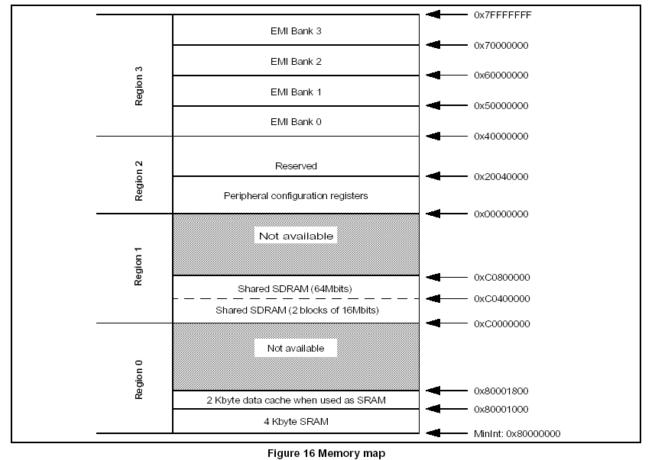
Memory is normally accessed by the load, store, block move and channel instructions. These will use data cache if it is enabled, and do not guarantee the order of accesses to different addresses. The device access instructions listed in
Figure 16 Memory map
MinInt: 0x80000000
4 Kbyte SRAM
2 Kbyte data cache when used as SRAM
0x80001800
0xC0000000
0x00000000
0x7FFFFFFF
0x80001000
Shared SDRAM (2 blocks of 16Mbits)
0xC0400000
0x40000000
EMI Bank 0
EMI Bank 1
EMI Bank 2
EMI Bank 3
0x50000000
0x60000000
0x70000000
Peripheral configuration registers
0x20040000
Region 0 Region 3 Region 2 Region 1
Not available
Reserved
Not available
0xC0800000
Shared SDRAM (64Mbits)
Table 44: Device access instructions on page 45 should be used when there is a need to bypass the data cache in a cacheable area, or if there is a need to know when a write occurs to an external device or memory area.
The address space is divided up for different uses as follows:
• Region 0: The bottom 4 Kbytes (or 6 Kbytes if the data cache is not used) is occupied by on-chip SRAM.
• Region 1: The 8 Mbyte area from 0xC0000000 to 0xC07FFFFF is for SDRAM, which is shared with the MPEG decoders. Register bit MY64 of the CFG_DRC register selects either of the following memory modes:
• 16Mb SDRAM memory mode (1 or 2 units), address space 0xC0000000 to 0xC03FFFFF
• 64Mb SDRAM memory mode, address space 0xC0000000 to 0xC07FFFFF
• Region 2: The area from 0x00000000 to 0x3FFFFFFF (region 2) is dedicated to memory-mapped or commandmapped on-chip peripheral registers.
• Region 3: 0x40000000 to 0x7FFFFFFF is for external memory and peripherals, accessed through the EMI.
Label
Address (byte)
Use
Start Finish
BootEntry 0x7FFFFFFE Boot entry point
0x70000000 0x7FFFFFFF EMI bank 3, normally used for boot ROM. DRAM/SDRAM not supported.
0x60000000 0x6FFFFFFF EMI bank 2: DRAM/SDRAM not supported
0x50000000 0x5FFFFFFF EMI bank 1: DRAM or SDRAM supported
0x40000000 0x4FFFFFFF EMI bank 0: DRAM or SDRAM supported
0x20040000 0x3FFFFFFF Reserved
0x20030000 0x2003FFFF Programmable transport interface (PTI) (64 Kbytes)1
0x20028000 0x2002FFFF Reserved
0x20027000 0x20027FFF IEEE1394 link layer interface (LLI)1
0x20026000 0x20026FFF Block move DMA controller1
0x20025000 0x20025FFF IEEE1284 parallel port1
0x20024000 0x20024FFF Teletext interface1
0x20012000 0x20023FFF Reserved
0x20011000 0x20011FFF Interrupt level controller1
0x20010000 0x20010FFF PIO port 4 controller1
0x2000F000 0x2000FFFF PIO port 3 controller1
0x2000E000 0x2000EFFF PIO port 2 controller1
0x2000D000 0x2000DFFF PIO port 1 controller1
0x2000C000 0x2000CFFF PIO port 0 controller1
0x2000B000 0x2000BFFF PWM and counter controller1
0x2000A000 0x2000AFFF Synchronous serial controller (SSC) 11
0x20009000 0x20009FFF Synchronous serial controller (SSC) 01
0x20008000 0x20008FFF SmartCard interface 11
0x20007000 0x20007FFF SmartCard interface 01
Table 51 STi5512 memory map
0x20006000 0x20006FFF Asynchronous serial controller (ASC) 31
0x20005000 0x20005FFF Asynchronous serial controller (ASC) 2 (SmartCard 0)1
0x20004000 0x20004FFF Asynchronous serial controller (ASC) 11
0x20003000 0x20003FFF Asynchronous serial controller (ASC) 0 (SmartCard 1)1
0x20001000 0x20002FFF Reserved
0x20000400 0x20000FFF Low power controller1
0x20000000 0x200003FF Interrupt controller1
0x00005002 0x1FFFFFFF Reserved
0x00005000 0x00005001 MPEG control register
0x00004000 0x00004FFF Cache configuration1
0x00003000 0x00003FFF Diagnostic controller unit (DCU)1
0x00002000 0x00002FFF External memory interface (EMI)1
0x00000000 0x00001FFF Audio, video, DENC and sub-picture
0xC0400000 0xFFFFFFFF Reserved
0xC0000000 0xC03FFFFF SMI SDRAM: Video/Audio, OSD memory, CPU user code, data and stack.
0x80001800 0xBFFFFFFF Reserved
0x80001000 0x800017FF Internal SRAM if the data cache is not enabled. User code, data and
stack.
MemStart 0x80000140 0x80000FFF Internal SRAM: < 4 Kbytes user code, data and stack
0x80000130 0x8000013F Low priority Scheduler trapped process
0x80000120 0x8000012F Low priority Scheduler trap handler
0x80000110 0x8000011F Low priority SystemOperations trapped process
0x80000100 0x8000010F Low priority SystemOperations trap handler
0x800000F0 0x800000FF Low priority Error trapped process
0x800000E0 0x800000EF Low priority Error trap handler
0x800000D0 0x800000DF Low priority Breakpoint trapped process
0x800000C0 0x800000CF Low priority Breakpoint trap handler
0x800000B0 0x800000BF High priority Scheduler trapped process
0x800000A0 0x800000AF High priority Scheduler trap handler
0x80000090 0x8000009F High priority SystemOperations trapped process
0x80000080 0x8000008F High priority SystemOperations trap handler
0x80000070 0x8000007F High priority Error trapped process
0x80000060 0x8000006F High priority Error trap handler
0x80000050 0x8000005F High priority Breakpoint trapped process
TrapBase 0x80000040 0x8000004F High priority Breakpoint trap handler
0x80000014 0x8000003F Reserved.
0x80000010 0x80000013 Link0 (boot) input channel
0x80000004 0x8000000F Reserved
MinInt 0x80000000 0x80000003 Link0 output channel
Label
Address (byte)
Use
Start Finish
Table 51 STi5512 memory map
9.2 System memory use
Certain sections of the address space are reserved for system use as follows:
• The locations below the address MemStart at the bottom of memory are dedicated to processor use. The address of MemStart is returned by the ldmemstartval instruction.
• When booting from ROM, the system boots from the predefined location BootEntry (0x7FFFFFFE) at the top of memory.
Areas of memory reserved for processor use should not be accessed directly. Special instructions are provided for manipulating these areas. The special address MemStart marks the base of user memory space. Peek and poke use the two words above MemStart, i.e. memory locations 0x80000140 to 0x80000147. These words should not be used by the application if it is to be debugged via the OS-Link. The use of peek and poke is described in
Chapter 12.
9.2.1 Subsystem channels memory
Each channel based DMA subsystem is allocated a word of storage below MemStart. This is used by the processor to store information about the state of that channel. This information should not normally be examined directly, although debugging kernels may need to do so.
Interrupting DMA subsystems do not have a channel word allocated and rely on interrupts to perform synchronization with the processes running on the processor. Note : on a STi5512 device, there is only one channel based DMA subsystem, the OS-Link.
9.2.2 Boot channel
The subsystem channel which is a link input channel, is identified as a ‘boot channel’. When the processor is reset and is set to boot from link, it waits for boot commands on this channel. In the case of STi5512 this is the OS link channel
Link0.
9.2.2.1 Memory for trap handlers
The area of memory reserved for trap handlers is broken down hierarchically:
• Each high/low process priority has a set of trap handlers
• Each set of trap handlers has a handler for each of the four trap groups
• Each trap group handler has a trap handler structure and a trapped process structure
• Each of the structures contains four words
The contents of these addresses can be accessed via ldtraph, sttraph, ldtrapped and sttrapped instructions.
9.2.3 Boot ROM
When the processor boots from ROM, it jumps to a boot program held in ROM with an entry point 2 bytes from the top of memory at 0x7FFFFFFE. These 2 bytes are used to encode a negative jump of up to 256 bytes down in the ROM program. For large ROM programs it may then be necessary to encode a longer negative jump to reach the start of the routine.
1. Registers accessed via CPU device accesses

